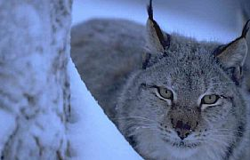
Lynx (Lynx lynx)
The Lynx belongs to the feline family of the animal kingdom.

Appearance: The fur has dots, with a yellow-red-brown first coat that gets lighter in the winter. The tail is short and tipped with black.
On the ears it has long black tufts of fur and white dots. And it has a white stripe under its eyes. The hind legs are long and the paws are big, it makes it easier to walk in snow. They usually are between 80 to 130 cm long and a grown up animal weights about 16 to 25 kg.

Food: The most important food for the Lynx is hare, but it can adopt its food habits so that it fits its eating habits.

Distribution: It came to Sweden after the ice age, which was about 9000 years ago.
The lynx is spread all over the northern half of the earth, in Europe, Asia and in America. The Lynx is a shy animal and it lives alone in mountain- and steep terrain.

Reproduction: Takes place from Mars to April. And between May and June the Lynx kids are born. The Lynx female does normally give birth to 2 or 3 kittens. The mother are responsible for the children while they grow up, they stay with the mother about a year. When the kids are about two year they leave the mother.

The Lynx have a good vision in the daylight, but in the night the sight gets 7 times better. Lynxes have hair under their paws to protect them against snow and cold.
And it can draw back and out their claws, just like a cat, during the hunt or just to get a good foothold.

